Description  QMC-CRYOBRD-02-offset is a versatile, full-package cryogenic breadboard designed for the most demanding low-temperature experiments. Precision-machined from gold-plated OFHC copper, it delivers excellent thermal performance and long-term durability. A near–light-tight architecture combines cryogenic mu-metal shielding to suppress magnetic and electromagnetic interference. The innermost sample space features an infrared gold-plated copper shield. A fully non-magnetic interior with 16 non-magnetic SMA bulkhead feedthroughs enables flexible, high-density signal routing. Designed to mount directly to the mixing-chamber flange of most dilution refrigerators, QMC-CRYOBRD-02-offset offers a turnkey solution for ultra-low-noise cryogenic research. QMC-CRYOBRD-02-offset, offsets the vertical breadboard from the center providing more space on one side of the breadboard to mount larger components. | 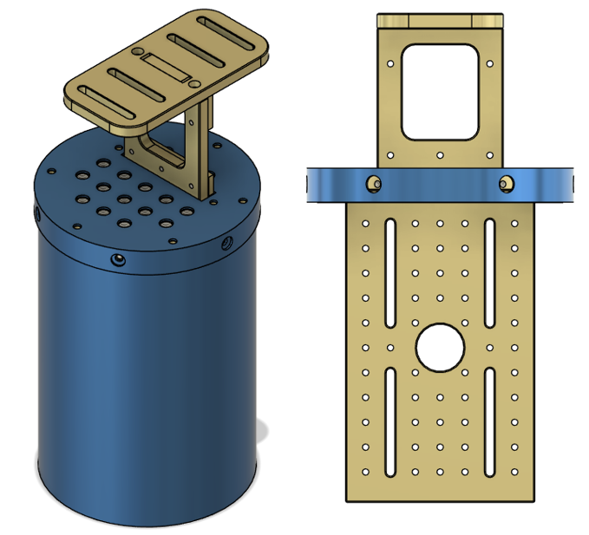  QMC-CRYOBRD-02-offset

Key Features
- Vertical Breadboard offset 12.7 mm from center to provide more space to facilitate mounting of larger components.
- 16x SMA nonmagnetic bulkhead feed-thrus
- 16x nonmagnetic SMA caps to shield ports which are not in use
- Breadboard consists of 52X M3 threaded holes, and 4x M3 screw clearance slots for flexibility in mounting samples
- Magnetic shielding includes Amuneal A4k shield.
- Gold plated infrared inner shield
- Durable Nickel-free gold plating on all copper parts
- DC feedthrough options available

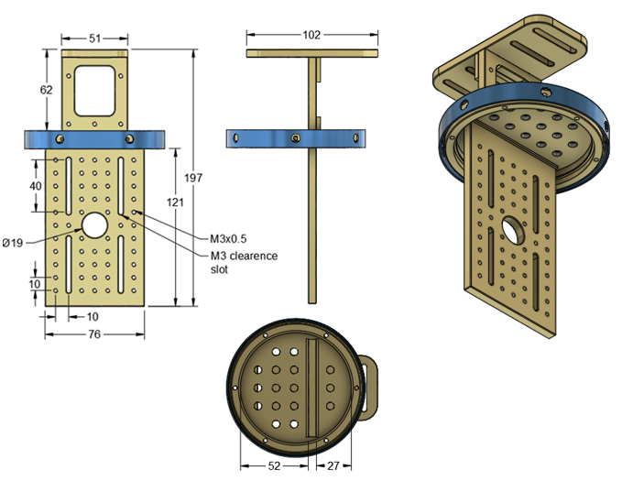

Shielding  - 86 mm ID OFHC Copper Infrared Shield  - Amuneal A4K 0.04” Mu-metal magnetic shield | 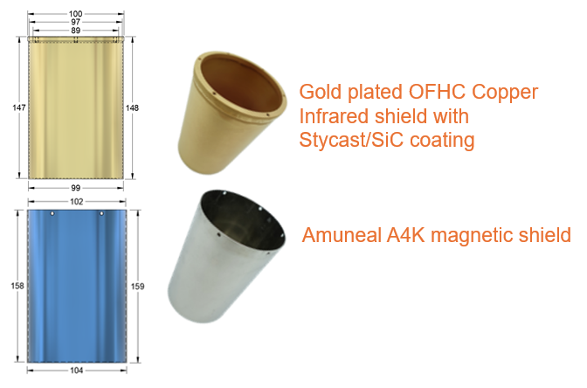

Breadboard  - Breadboard material OFHC copper with hard durable gold plating with thickness of 30 microinches.  - Breadboard consists of 52X M3 threaded holes, and 4x M3 screw clearance slots for flexibility in mounting samples. | 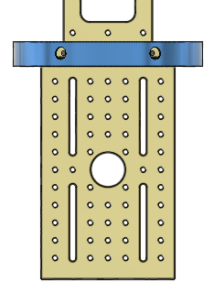

Mounting  - Breadboard system can be mounted to a mixing chamber flange of a dilution refrigerator through 4x M4 clearance slots allowing for flexibility in mounting position of measurement system. Clearence slots are offset by 2 cm for easy mounting to hole patterns found in most dilution refrigerator systems. | 