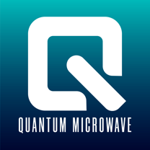
www.QuantumMicrowave.com
 | P/N: QMC-CRYOTERM-DC40 DC-40 GHz Cryogenic Termination
 | Features  - Frequency: DC to 40 GHz  - 50 Ohm Load  - Excellent RF Match  - Non-superconducting  - NiCr on Crystalline Quartz  - Silver Epoxy bonded  - Machined OFHC block, gold plated  - 2.92mm male connector  - Stackable mechanical design  - Operates in the mK Temperature Range | 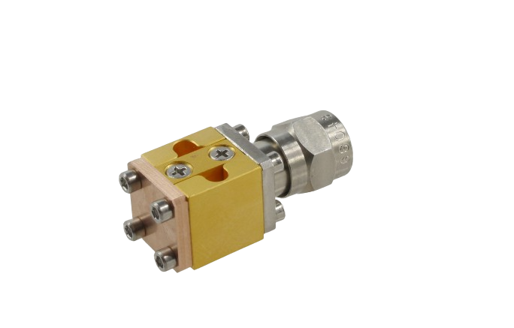
Parameter | Specification | Notes
Frequency Range | DC to 40 GHz
Return Loss | 18dB typ.
Connectors | 2.92mm (m)
Max Power Handling | 100 mW

Measured Data, Typical
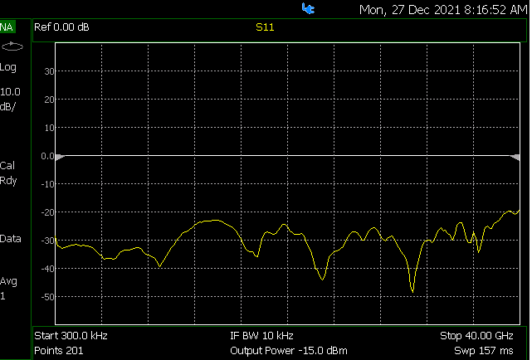

Outline Drawing [inches]

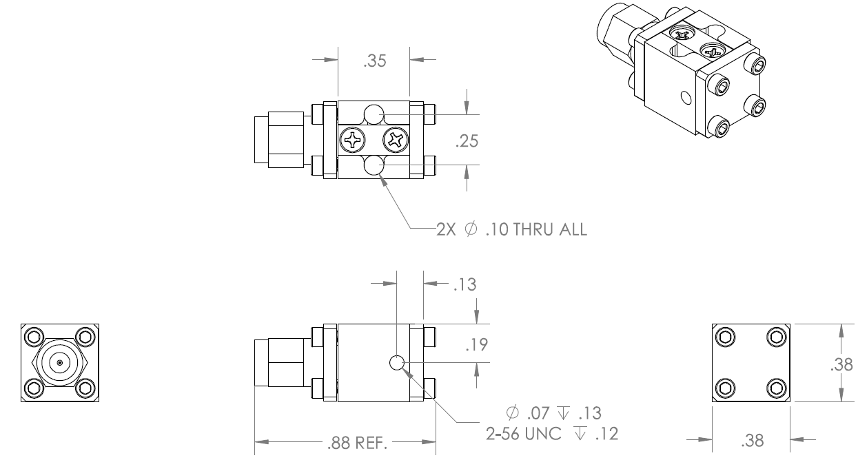

Quantum Microwave Components Phone 857-499-0071, Fax 888-893-7188

